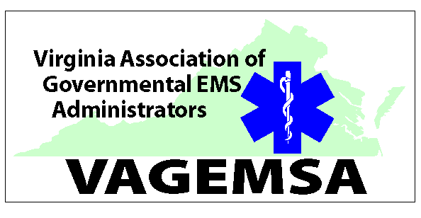
Meeting Agenda Friday, August 4, 2107
Richmond Marriott West –Glen Allen, VA

10:30 am

- Welcome, Moment of Silence for our fallen, Pledge of Allegiance and Introductions

- Approval of minutes from May 5, 2017

- Officer’s Reports

- Treasurer’s Report

- OEMS Report

- Lobbyist Report

- OLD BUSINESS
EMS Training Funds Update

- NEW BUSINESS
EMT-I Certification Position
Membership Application - Augusta County Fire and Rescue

- Committee Reports – As time permits. All members are encouraged to review the committee minutes contained in the Quarterly report

  - Communications:
  - Provider Health & Safety:
  - Emergency Management:
  - FARC:
  - Legislative & Planning:
  - Training and Certification:
  - Medevac:
  - Medical Direction:
  - Rules and Regulations:
  - Transportation:
  - Symposium:
  - Workforce Development: 13. E911:
- Traffic Incident Management:
- Mobile Integrated Healthcare

